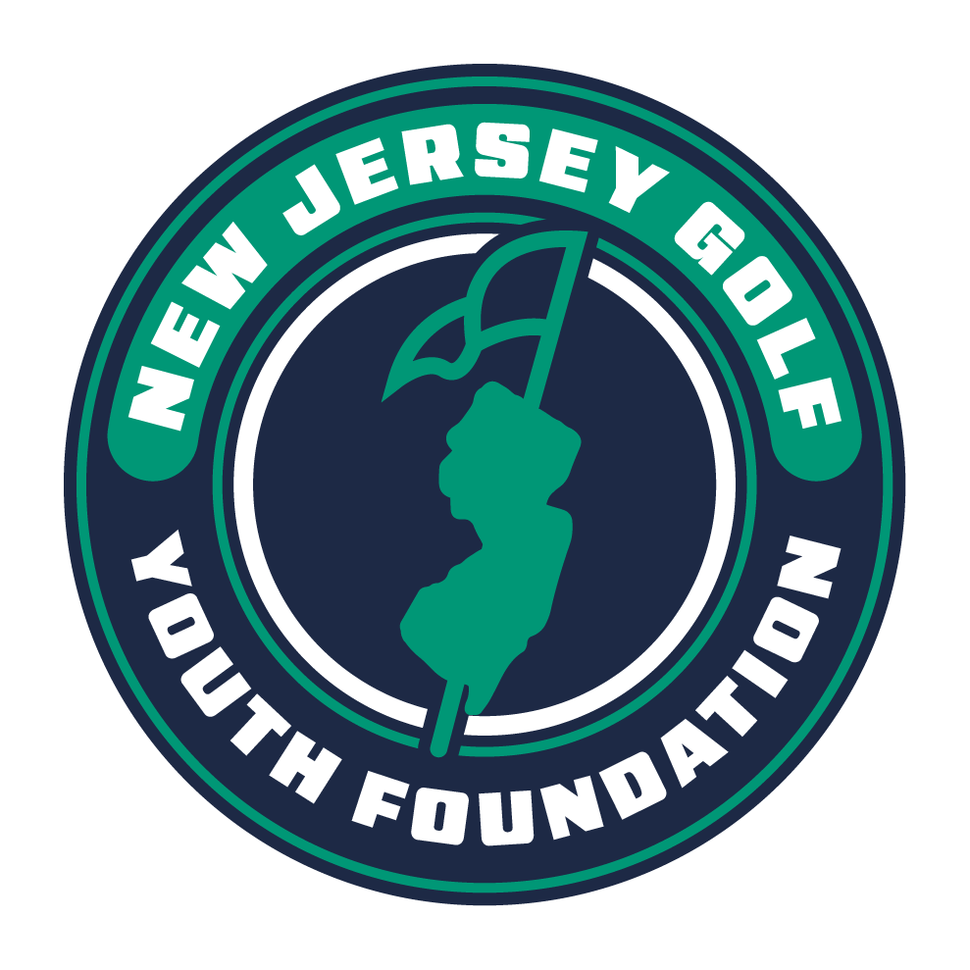
NJ Golf Youth Foundation
Grant Application

The New Jersey Golf Youth Foundation was established to promote the growth of the game through its instructional clinics and grant program. We are pleased that your organization is interested in our program.

Please complete the following form and provide any additional documentation which you feel supports your organization and its mission.

Name of Organization: _______________________________________________________________________________________________

Mailing Address (Street, City, Zip): _________________________________________________________________________________

_________________________________________________________________________________________________________________________
Contact Name & Title:________________________________________________________________________________________________

Daytime Telephone: ______________________________________ Email: ___________________________________________________

Organization’s Website: _____________________________________________________________________________________________

Organization’s Mission (please use separate sheet if necessary): _______________________________________________

_________________________________________________________________________________________________________________________
_________________________________________________________________________________________________________________________
General Description of Function/Purpose of Organization: ______________________________________________________

_________________________________________________________________________________________________________________________
_________________________________________________________________________________________________________________________
_________________________________________________________________________________________________________________________
Number of Years in Existence: _____ Non-Profit Tax Identification Number: ____________________________________

Does your organization conduct golf-related programs? __________

Requested Amount of Contribution: $ ______________________ Date Submitted: ____________________________________

New Jersey Golf – 3 Golf Drive, Suite 206, Kenilworth, NJ 07033
Phone: (908) 241-GOLF Email: info@njgolf.org Web: www.njgolf.org

